***Processing Post Requests with Body Parser***

Search **list of http status codes**

app.post("/",function(req,res){

res.send("Thanks for posting that!");

});

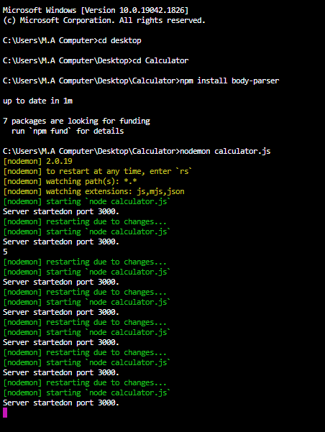

**npm install body-parser**

**Code:**

**Difference between value and placeholder**

**Index.html:**

<!DOCTYPE html>

<html lang="en" dir="ltr">

<head>

<meta charset="utf-8">

<title>Calculator</title>

</head>

<body>

<h1>Calculator</h1>

<form action="/" method="post">

<input type="text" name="n1" placeholder="First Number">

<input type="text" name="n2" placeholder="Second Number">

<button type="submit" name="submit">Calculate</button>

</form>

</body>

</html>

**Calculator.js:**

//jshint esversion:6

const express = require('express');

const bodyParser = require("body-parser");

const app = express();

app.use(bodyParser.urlencoded({

extended: true

}));

app.get("/", function(req, res) {

//console.log(req);

//res.send("Hello, World!");

//res.sendFile("index.html"); //For whole file like html file "location"

//if path is not known then

//console.log(__dirname); //see path

res.sendFile(__dirname + "/index.html");

});

app.post("/", function(req, res) {

//console.log(req.body.num1);

var num1 = Number(req.body.n1);

var num2 = Number(req.body.n2);

var result = num1 + num2;

res.send("The result of the calculation is: " + result);

//res.send("Thanks for posting that!");

});

app.listen(3000, function() {

console.log("Server startedon port 3000.");

});

**Path.js:**

console.log(__dirname);